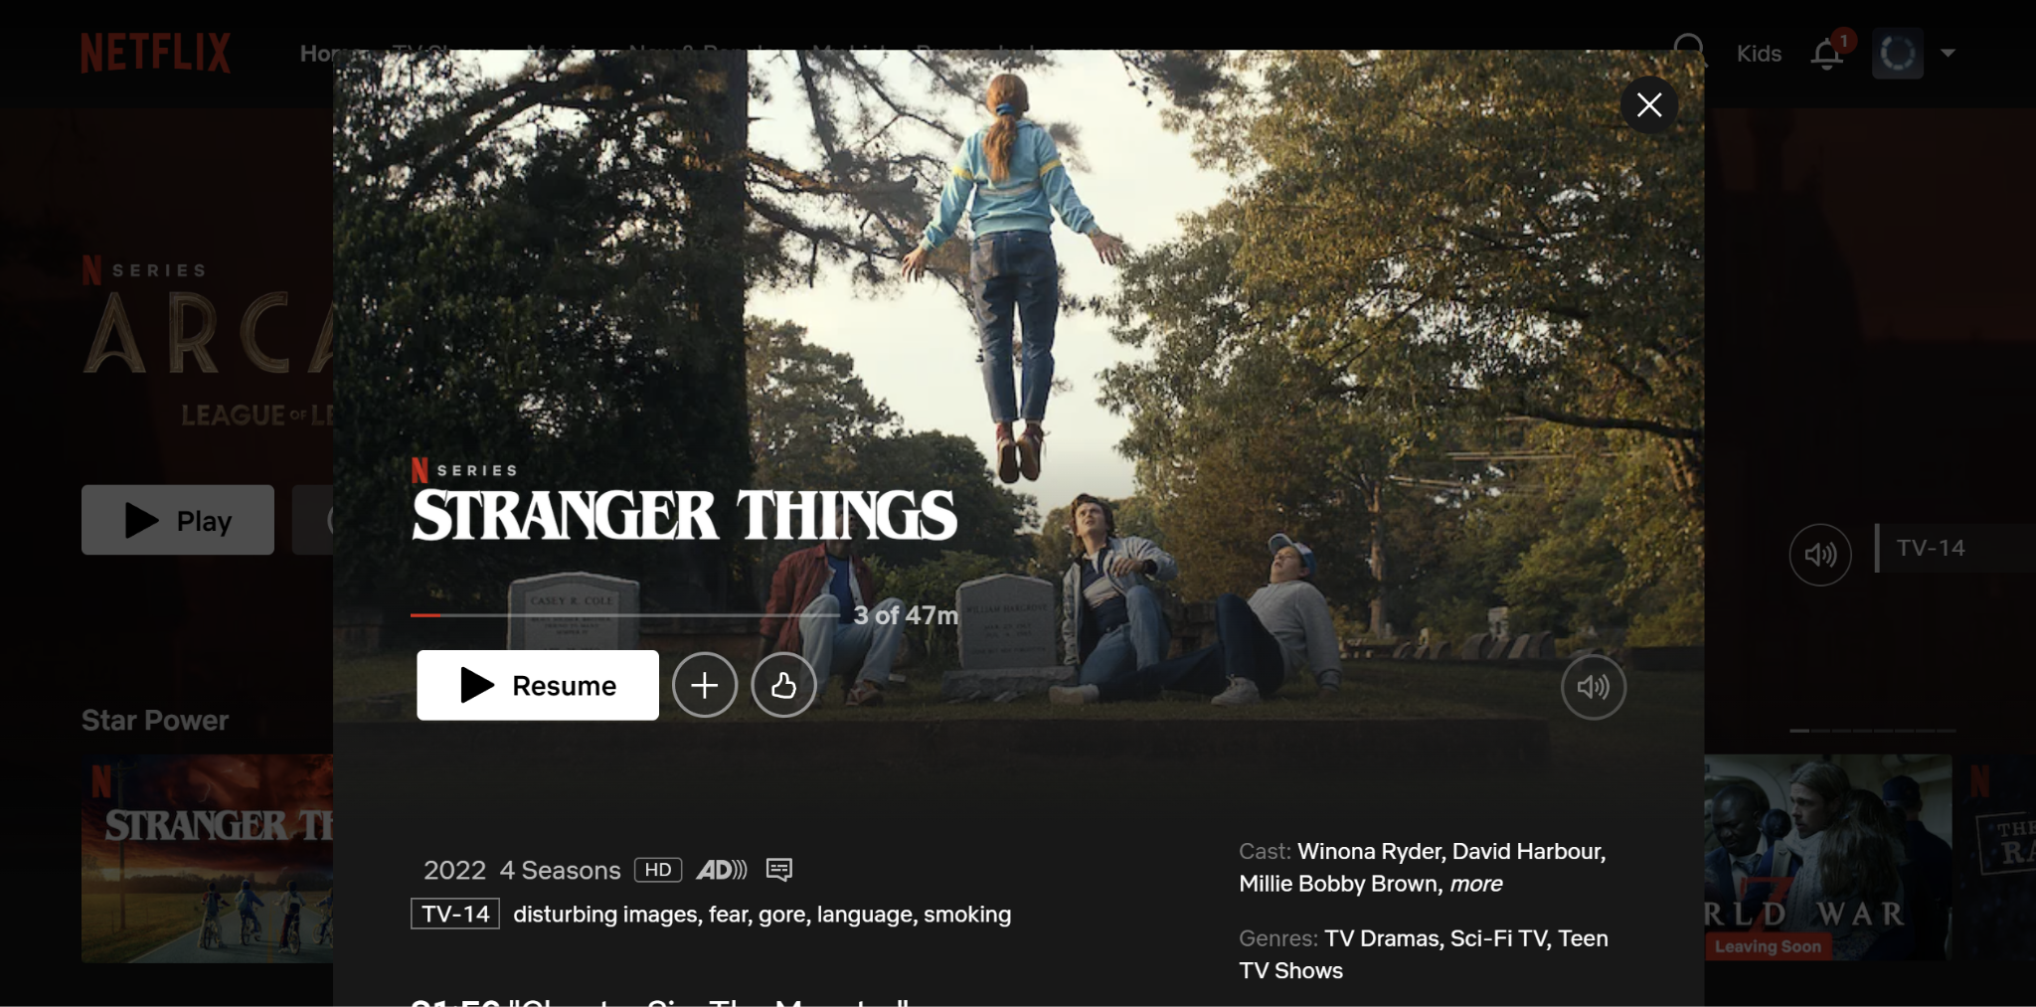

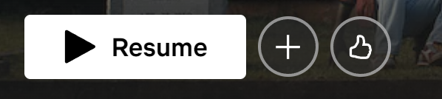

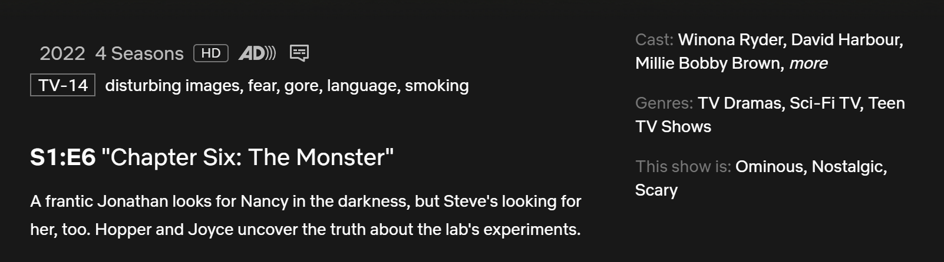

**Header Section (Netflix Branding)**

* Netflix logo at the top-left corner.
* Navigation links like "Home," "TV Shows," "Movies," and others next to the logo.
* A user profile icon and possibly notifications and settings icons on the right.

**Content Section (Main Feature Box)**

The title of the series ("Stranger Things") is displayed prominently on the image.

There are options to "Resume," add to a list, or download the content.

An overlay with the play button at the center of the image.

Additional metadata about the content: year, rating (TV-14), and genres (TV Dramas, Sci-Fi TV).

**Side Content**

Additional information like cast members ("Winona Ryder," "David Harbour," etc.).

recommendations or further options under the featured series.